Title of Article times new roman in bold
Author Name,¹* Co-Author Name(s)²
¹Affiliation Information: Street Address/Box Number, City, State, Postal Code
²Affiliation Information: Street Address/Box Number, City, State, Postal Code
*Corresponding author. Email: email@email.com
Abstract
Please prepare an informative summary. As with an abstract, the summary should provide information on the purpose of the study, methods or procedures, results, discussion, and concluding remarks or interpretation of the results. If feasible, it should also indicate the meaning or importance of the work. The summary should be a self-contained statement giving the reader a clear indication of the purpose and content of the paper.
Keywords
Please select up to five brief phrases which describe the content of your extended abstract, separated by semicolons.
Introduction
The introduction should present scientific background for the research topic and a clear statement of the objective(s) of the work [1]. If you use Endnote to insert references, you may download the Endnote output style at http://www.nmletters.org/media/Nano-Micro_Letters.ens to format your references [2, 3].
Methods
The methods section should describe the design, materials, measurement methods, procedures, and statistical methods for the study. Measurement and statistical methods [4] should be mentioned, but for routine methods, a reference rather than a description is recommended.
Results and Discussion
Extended abstracts may include tables and figures. Tables and figures should be inserted in the text after and close to where they are first mentioned. Do not extend the tables or figures beyond the margins. All the tables and figures should be centred.
Please insert figures as ‘picture’ (e.g. tif, jpg, eps or pdf), not as ‘objects’ or spreadsheets. All figures must have suitable captions below the figure. (Leave one blank line before and after table and figures.). In addition, for high quality publishing, please also upload separate figure files when uploading your article file. Thank you.
Table 1. Table caption.
Content | Column 1 | Column 2
Row 1 | Content 1 | Content 3
Row 2 | Content 2 | Content 4

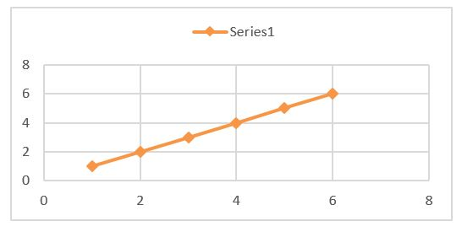
Figure 1. Figure Caption.
Conclusions
In the Conclusions section, do not simply repeat your results or discussion, but provide some overall observations regarding the findings, such as their applicability in other settings or applications. This section should tell the reader what the importance of the work is for others including researchers, building designers, owners and operators, or occupants. We look forward to seeing you at the Nano-Micro Conference 2018.
Acknowledgement
A short section may acknowledge assistance. Sources of financial aid should always be noted.
References
1. Z.L. Wang, D. Xu, J.-J. Xu, X.-B. Zhang, Oxygen electrocatalysts in metal–air batteries: from aqueous to nonaqueous electrolytes. Chem. Soc. Rev. 43(22), 7746–7786 (2014). https://doi.org/10.1039/C3CS60248F
2. Z. Yang, J. Zhang, M.C.W. Kintner-Meyer, X. Lu, D. Choi, J.P. Lemmon, J. Liu, Electrochemical energy storage for green grid. Chem. Rev. 111(5), 3577–3613 (2011). https://doi.org/10.1021/cr100290v
3. G.H. Yue, Y.D. Lin, X. Wen, L.S. Wang, D.L. Peng, SnS homojunction nanowire-based solar cells. J. Mater. Chem. 22(32), 16437–16441 (2012). https://doi.org/10.1039/c2jm32116e
4. M.X. Wang, G.H. Yue, Y.D. Lin, X. Wen, D.L. Peng, Z.R. Geng, Synthesis, optical properties and photovoltaic application of the SnS quasi-one-dimensional nanostructures. Nano-Micro Lett. 5(1), 1–6 (2012). https://doi.org/10.1007/BF03353724
5. B. Scrosati, J. Hassoun, Y.-K. Sun, Lithium-ion batteries. A look into the future. Energy Environ. Sci. 4(9), 3287–3295 (2011). https://doi.org/10.1039/c1ee01388b

