Paper ID (To be added by Programme Committee)
DOI: (To be added by Publishing House)
Title of abstract times new roman in bold
Author Name,¹* Co-Author Name(s)²
¹Affiliation Information: Street Address/Box Number, City, State, Postal Code
²Affiliation Information: Street Address/Box Number, City, State, Postal Code
*Corresponding author. Email: email@email.com
Abstract
Please prepare an informative summary. As with an abstract, the summary should provide information on the purpose of the study, methods or procedures, results, discussion, and concluding remarks or interpretation of the results. If feasible, it should also indicate the meaning or importance of the work. The summary should be a self-contained statement giving the reader a clear indication of the purpose and content of the paper.
Keywords
Please select up to five brief phrases which describe the content of your extended abstract, separated by semicolons.
Introduction
The introduction should present scientific background for the research topic and a clear statement of the objective(s) of the work [1].
Methods
The methods section should describe the design, materials, measurement methods, procedures, and statistical methods for the study [2, 3]. Measurement and statistical methods [4] should be mentioned, but for routine methods, a reference rather than a description is recommended.
Results and Discussion
Extended abstracts may include tables and figures. Tables and figures should be inserted in the text after and close to where they are first mentioned. Do not extend the tables or figures beyond the margins. All the tables and figures should be centred.
Please insert figures as ‘picture’ (e.g. tif, jpg, eps or pdf), not as ‘objects’ or spreadsheets. All figures must have suitable captions below the figure. (Leave one blank line before and after table and figures.). In addition, for high quality publishing, please also upload separate figure files when uploading your article file. Thank you.
Table 1. Table caption.
Content | Column 1 | Column 2
Row 1 | Content 1 | Content 3
Row 2 | Content 2 | Content 4

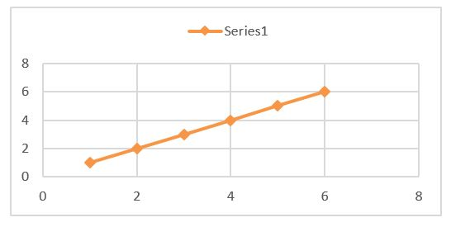
Figure 1. Figure Caption.
Conclusions
In the Conclusions section, do not simply repeat your results or discussion, but provide some overall observations regarding the findings, such as their applicability in other settings or applications. This section should tell the reader what the importance of the work is for others including researchers, building designers, owners and operators, or occupants. We look forward to seeing you at the Nano-Micro Conference 2018.
Acknowledgement
A short section may acknowledge assistance. Sources of financial aid should always be noted.
References
[1] P. D. Howes; R. Chandrawati; M. M. Stevens, Colloidal Nanoparticles as Advanced Biological Sensors. Science. 346, 1247390 (2014). doi:10.1126/science.1247390
[2] M. Kendall; I. Lynch, Long-term Monitoring for Nanomedicine Implants and Drugs. Nature Nanotechnology. 11, 206 (2016). doi:10.1038/nnano.2015.341
[3] J. Conde, N. Shomron, N. Artzi, Biomaterials for Abrogating Metastasis: Bridging the Gap between Basic and Translational Research. Advanced Healthcare Materials. 5, 2312 (2016). doi:10.1002/adhm.201600414
[4] M. Ferrari, Cancer Nanotechnology: Opportunities and Challenges. Nature Reviews Cancer. 5, 161 (2005). doi:10.1038/nrc1566

